Machine Learning 108-1

HW6

0856733 數據一 黃明翰

# **Data(image) Preparation**

## Data (image)



In use ***imageio*** to read image date in both algorithms, which can read image as array (100x100).

## Similarity matrix (W)



We will use similarity matrix in both algorithms for two input images. The matrix is made up by given **RBF kernel** 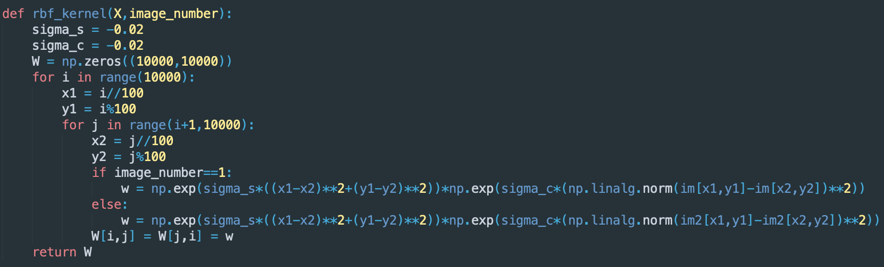

which is equivalent to

$$k\left(x,x^{'}\right)= e^{-γ_{s}{\left\|S\left(x\right)-S(x^{'})\right\|}^{2}}×e^{-γ_{c}{\left\|C\left(x\right)-C(x^{'})\right\|}^{2}}$$

Where $S\left(x\right)$ is the spatial information and $C\left(x\right)$ is the color information.

# **Kernel K-means**

## Initial Methods

I tried two different initial methods.

1. **Random assign**: randomly assign data point into class(0~k-1)   
   
2. **K-means++**: from Line 26 – Line 58  
   In this method, I’ll explain in pseudocode followed:  
   A. Randomly choose a data point as the first cluster  
   B. Calculate distances of each points to the closest clusters  
   C. Turn distance into probability and choose next cluster by probability(The farther the higher probability to be choosed)  
   D. Repeat B-C till find k cluster.  
   E. (from Line 47)Assign each point into their closet cluster.

## Clustering

After initial, I use the kernel data (similarity matrix) and the initial information to cluster data points into k(2~4) clusters.



First, calculate the distance from kernel data to the means: $$\left\|∅\left(x_{j}\right)-μ_{k}^{∅}\right\|=k\left(x_{j},x_{j}\right)-\frac{2}{\left|C_{k}\right|}\sum_{n}{α_{kn}k\left(x_{j},x_{n}\right)}+\frac{1}{{\left|C_{k}\right|}^{2}}\sum_{p}{\sum_{q}{α_{kp}α_{kq}k\left(x_{p},x_{q}\right)}}$$

Then cluster each point into closest cluster use ***argmin.***

Repeat this step until the difference in clustering result between two iteration converges. (By experiment, I set the stopping threshold < 50)

## Results

* Image 1
  + K=2

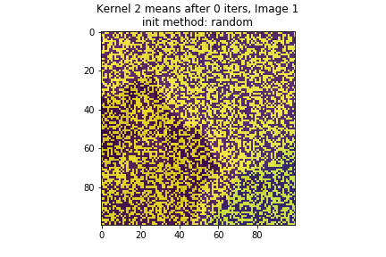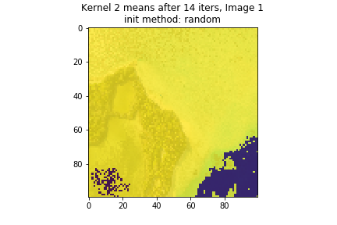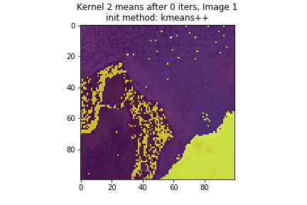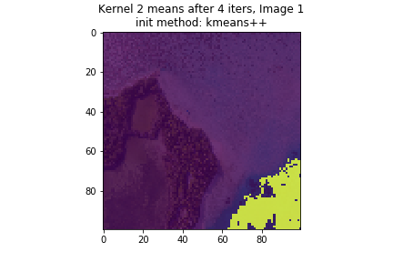

* + K=3

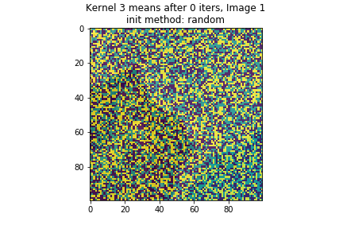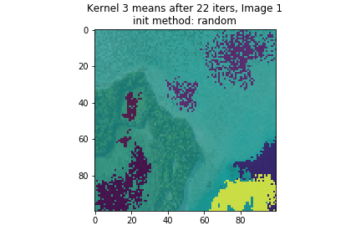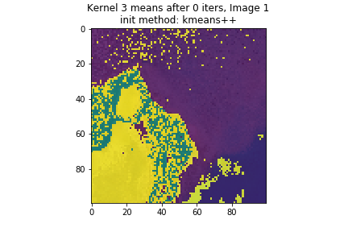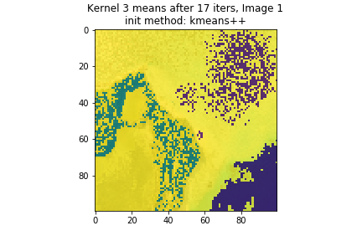

* + K=4

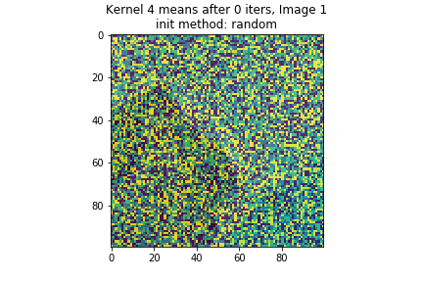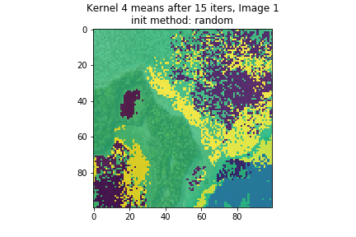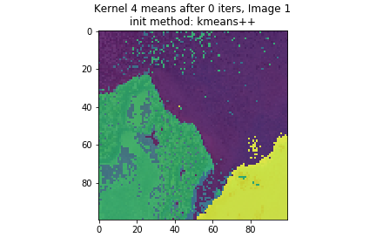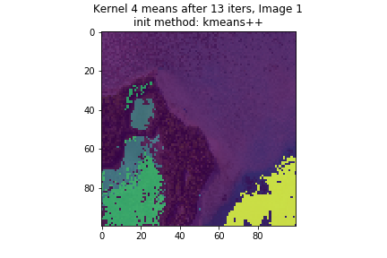

* Image 2
  + K=2  
    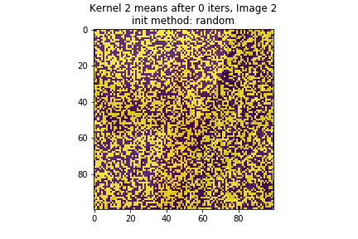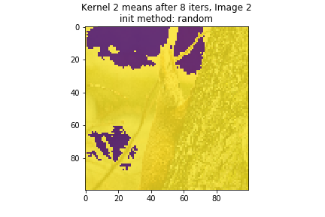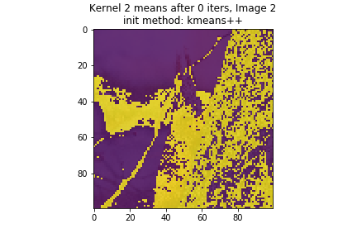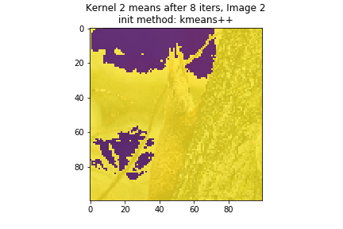
  + K=3

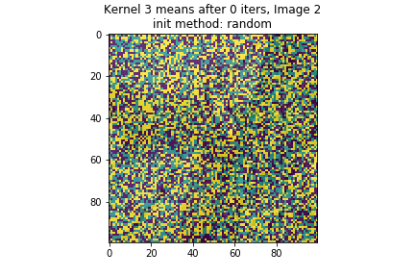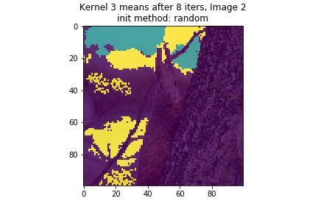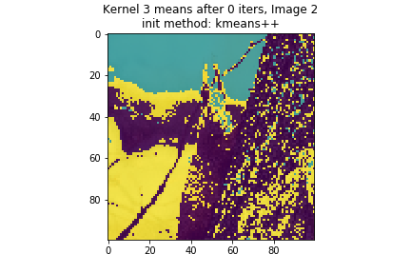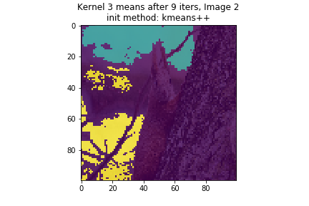

* + K=4

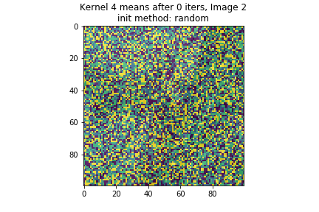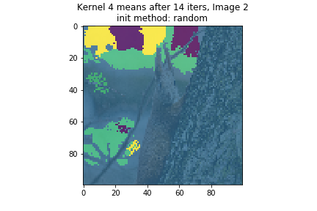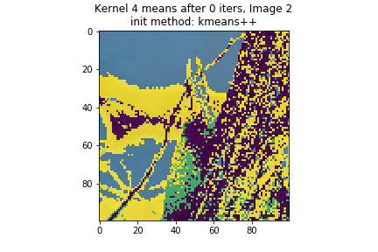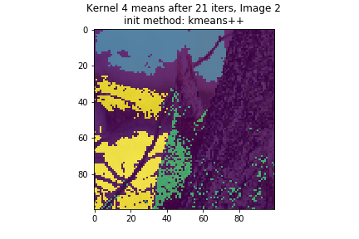

From the result we can see that in both input image, if we use kmeans++ as the initial method, since the starting center is far enough, it needs lesser time to converge and get more precise results.

# **Spectral Clustering**

## Ratio-Cut

To approximate the minimum of ratio-cut method, we can use unnormalized Laplacian ***L=D-W*** to approach, where ***D*** is the degree matrix, ***W*** is the similarity matrix.  


Then we find the eigenvalues and eigenvectors of ***L***, sort eigenvalues to find the top k+1 small eigenvalues and their eigenvectors. Since we use ***RBF kernel*** here, which cause the fully-connected graph, we start from the 2nd smallest eigenvalue and its eigenvector. Let ***U*** be the matrix containing these k eigenvectors.  
  
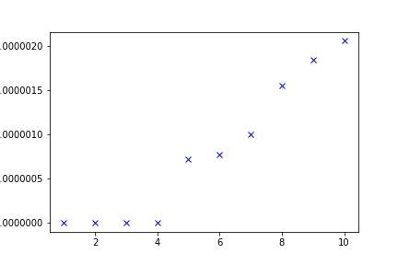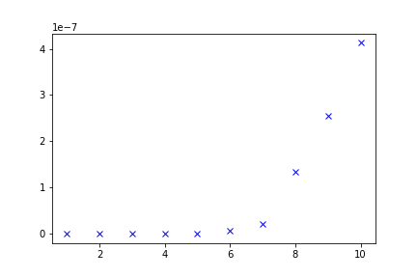(Sorted eigen-value of image1 and image2)

## Normal-Cut

We can use normalized Laplacian $L_{sym}=D^{-1/2}LD^{-1/2}$ to approximate the minimum of normalized-cut. Then we also start from the 2nd smallest eigenvalue and its eigenvector of $L_{sym}$, let ***U*** be the matrix of these k eigenvectors.  


Then we cluster the vector corresponding to the ***rows of U*** into k clusters with ***k-means*** algorithm.

## Initial Methods

I tried two different initial methods.

1. **Random assign**: randomly assign k data points to be the center  
    
2. **K-means++**: from Line 30 – Line 42  
   In this method, I’ll explain in pseudocode followed:  
   A. Randomly choose a data point as the first center  
   B. Calculate distances of each points to the closest center  
   C. Turn distance into probability and choose next center by probability(The farther the higher probability to be choosed)  
   D. Repeat B-C till find k centers.

## K-means

From Line 78 – Line 97, I implement the k-means algorithm:

1. Initial the centers using algorithm introduced aboved.
2. Cluster each point to their closest center (function classify, Line 45 – Line 52)
3. Update center according to the point in the corresponding cluster. (function update, Line 54 – Line 63)
4. Draw the result use matplotlib.

## Results

First line: normal-cut  
Second line: ratio-cut

* Image 1
  + K=2

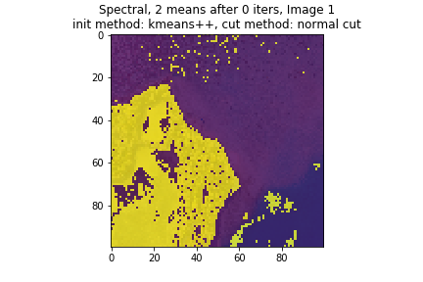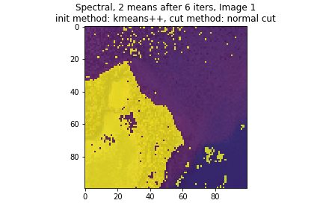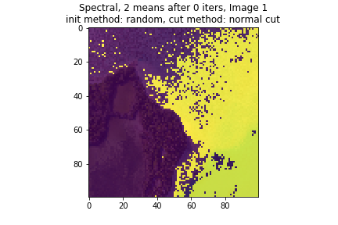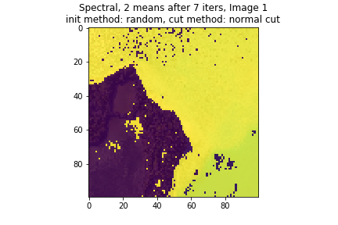

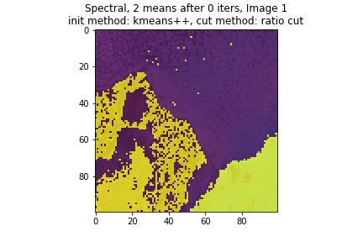 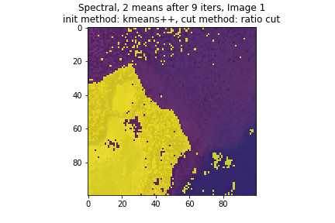 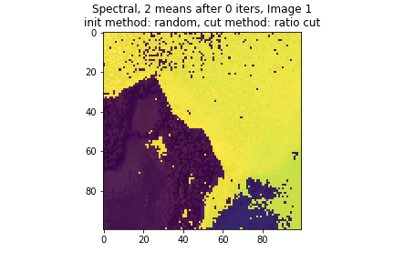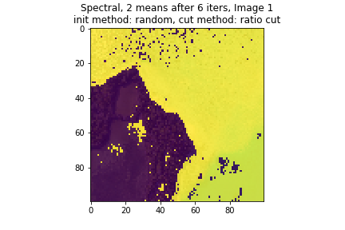

* + K=3

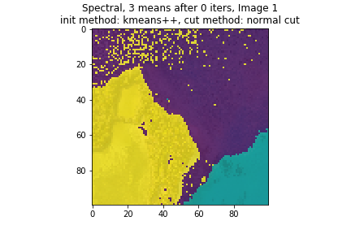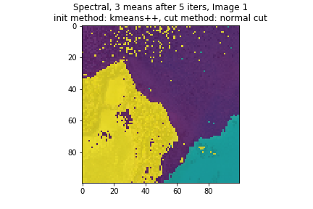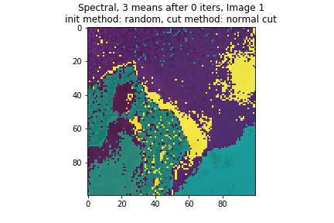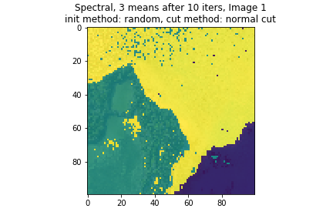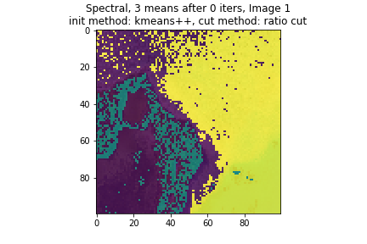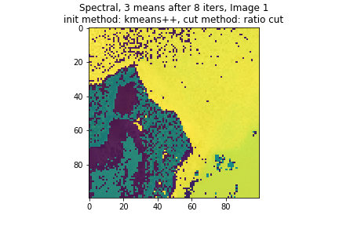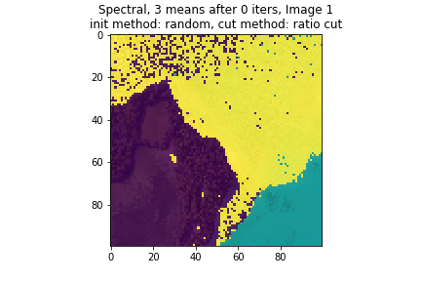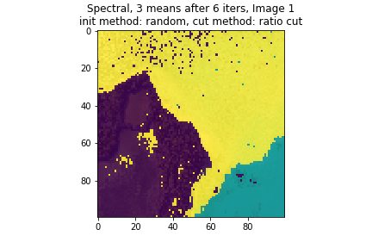

* + K=4

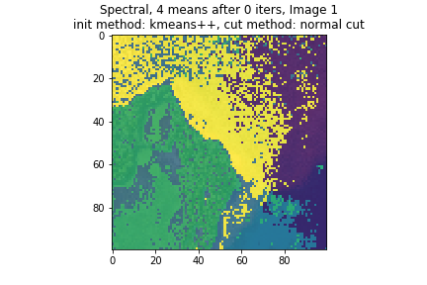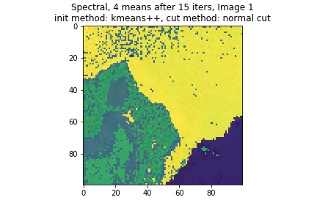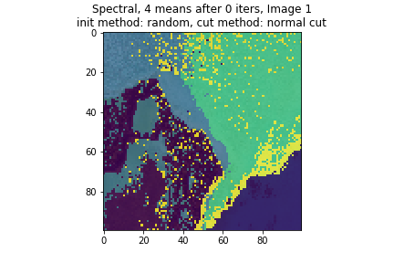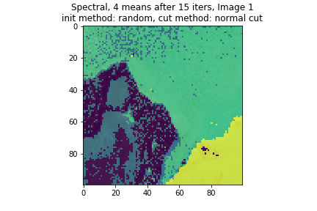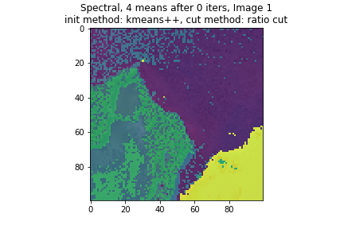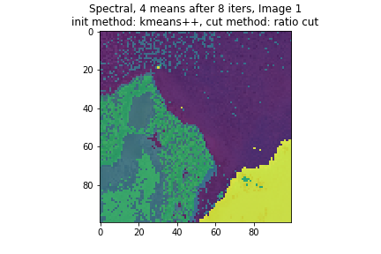 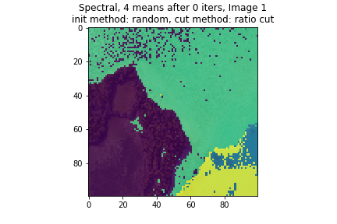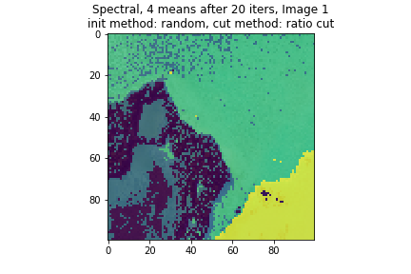

* Image 2
  + K=2

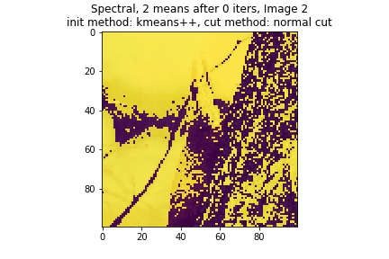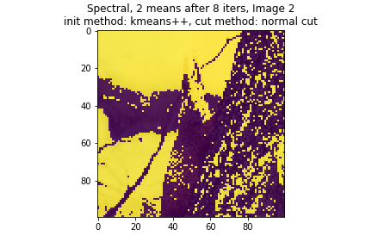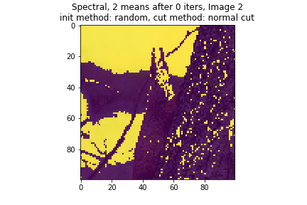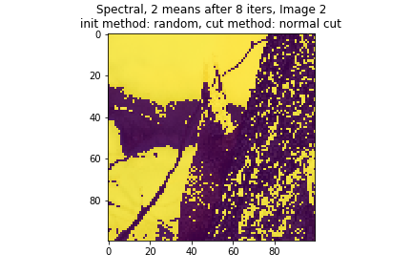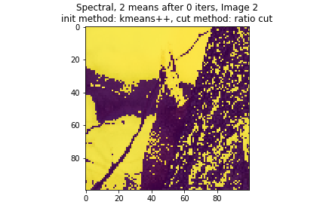 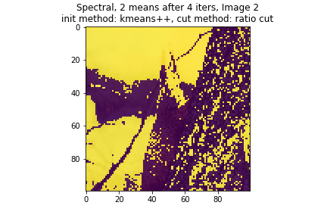 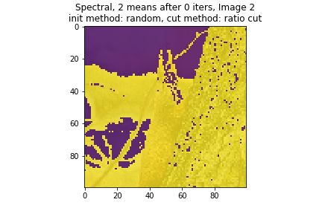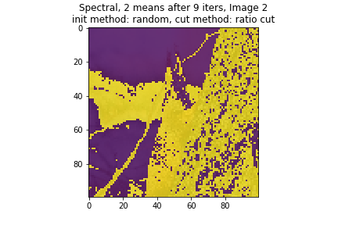

* + K=3

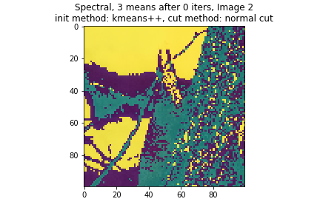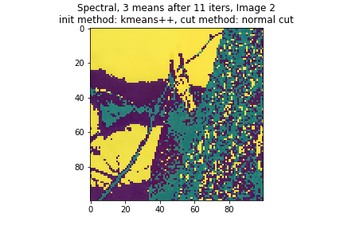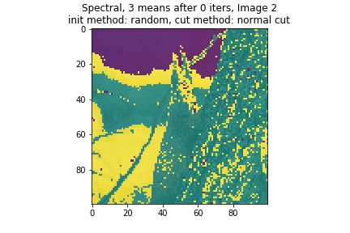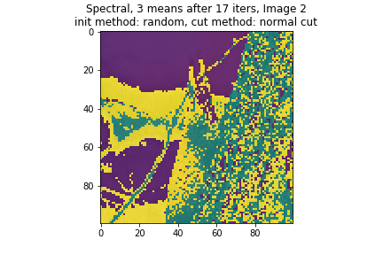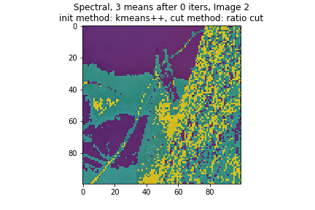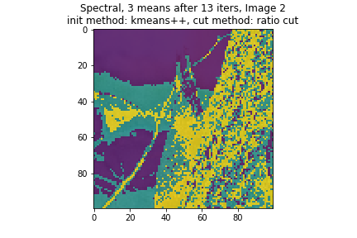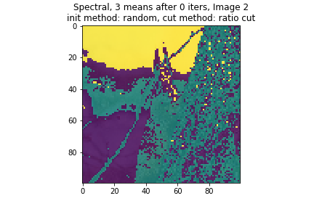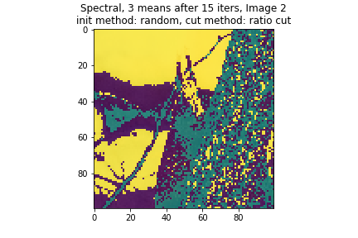

* + K=4

